# **University of Hertfordshire**

**Applied Data science – 1 assignment**

**Name:** Prudhvi Vardhan

**Id:** 22071880

**Dataset link:** https://www.kaggle.com/datasets/russellyates88/suicide-rates-overview-1985-to-2016

**Github:** https://github.com/pp23aai/AssignmentADS-1

# **Global Suicide Rates with Graphs**

**Introduction:**

Suicide is a huge problem all over the world, and it affects people of all ages and genders. To figure out how to prevent it, we need to understand how suicide rates have changed over time and how they vary by age and gender. This report uses data visualization to analyze global suicide rates from 1985 to 2015. The three graphs give us a better handle on trends over time, differences by age group, and variations by gender.

I picked the following graphs:

1. Line chart

2. Bar graph

3. A pie chart

**Graph 1: Worldwide suicide Totals Per 100K Pop by Region -Line chart**

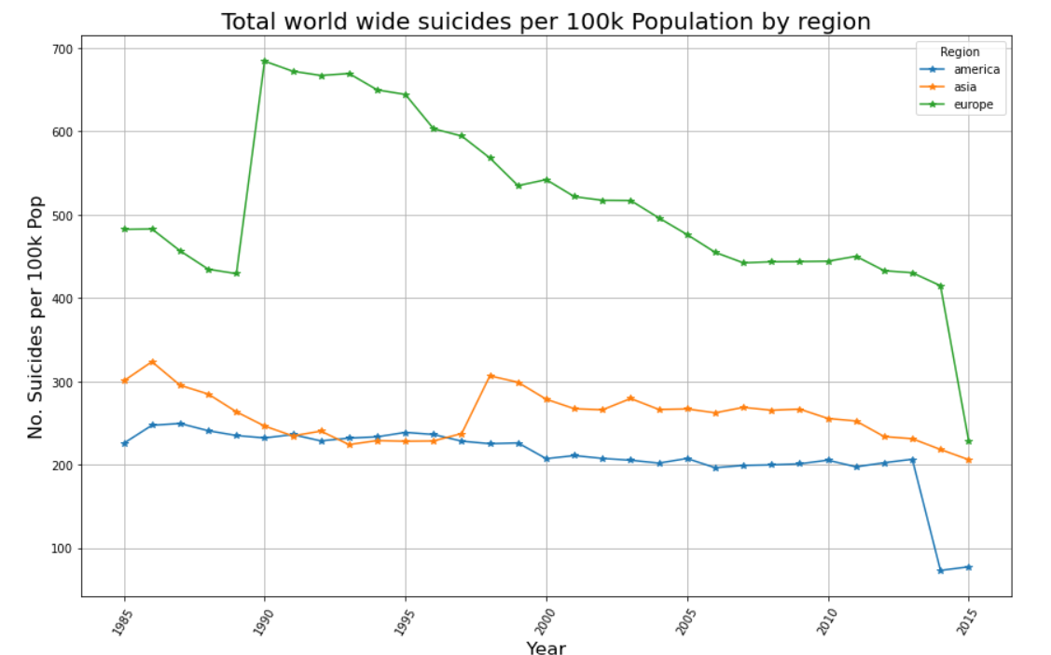

This graph is perfect for showing changes over time. The line chart shows global suicide rates per 100k people from 1985 to 2015 by region. It shows that the rates have decreased overall, but there were some spikes in the 1990s and 2000s.If we look at Europe specifically, we can see that it used to have higher suicide rates than Asia and the Americas, but the gap has narrowed recently.

**Graph 2: Total Global suicide’s by Age group in 2015 (Bar Chart)**

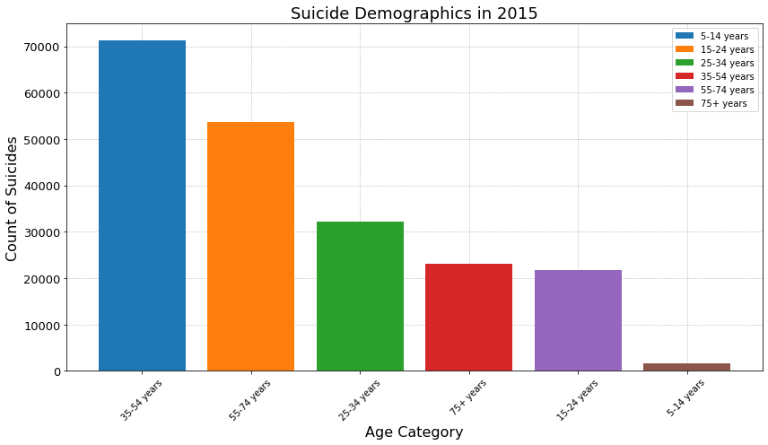

**Suicide Demographics by Age Group (2015):**

The bar chart for 2015 painted a vivid picture of how age impacts suicide rates. The tallest bars represented the age brackets with the most suicides, clearly showing that certain age groups bore a heavier burden of suicide numbers. This information is crucial for tailoring public health interventions to the age groups most at risk.

**Graph 3: The Pie that's Divided (Pie Chart)**

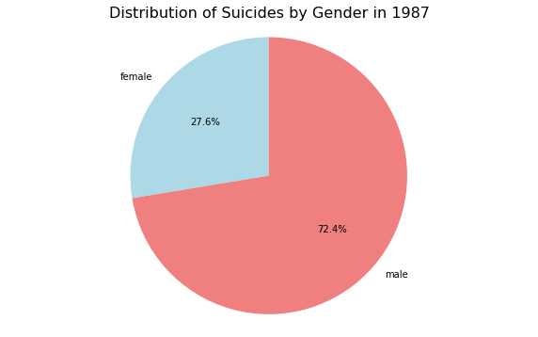

**Suicide Distribution by Gender (1987):**

In 1987, the gender gap in suicide rates was pronounced, with 91,836 suicides among men compared to 35,006 among women. Men's suicides were more than double that of women's, a stark reminder of the different patterns in how each gender experiences and deals with distress. Such data underscores the necessity for gender-sensitive mental health support.

**Conclusion:**

To sum up, these graphs reveal some important trends and variations in global suicide data. The line chart shows that overall rates have decreased, but there have been some concerning spikes in certain regions. The bar chart highlights higher rates among certain age groups, such as 25-54 year olds. And the pie chart underscores the disproportionate impact on males. While rates have declined, suicide remains a pressing global concern. We need to keep monitoring patterns and develop targeted interventions to address this crisis. The story told through these three graphs underscores the need for more research and resources devoted to suicide prevention globally.